Safety in the Classroom



Ergonomics and Employer Regulations

Name:
Form:
Teacher:


Introductions
It is important we can highlight the health and safety hazards within both the ICT classroom and when using IT in a career. Whilst common sense plays a big role in the use of IT, there are some rules we should follow in keeping both ourselves and our data safe.
Our data is our own, and we should be wary of where we share our data and who we share our personal information with.

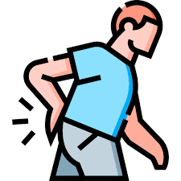
Back Against the Wall
Backache can be caused by sitting for long periods of time in the same position and having your chair and the wrong height. There is also the possibility of damage to the spine being caused if this is not addressed.
To Combat this potential threat we can:
- Use an adjustable chair
- Take regular breaks
- Use a footrest
- Change your sitting position (don’t slouch)

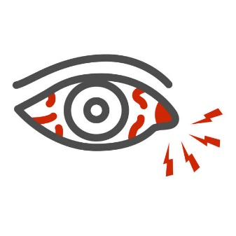
A Sight for sore eyes
Eye strain is caused by continuously looking at a screen for an extended period of time. Reflection and glare from bright lights can make it worse.
Constantly straining your eyes can result in headaches, sore eyes and a worsening of your eyesight.
To combat this potential threat:
- Use suitable screen size
- Take regular breaks
- Fit blinds to windows
- Position your monitor away from direct sunlight
- Use an anti-glare screen

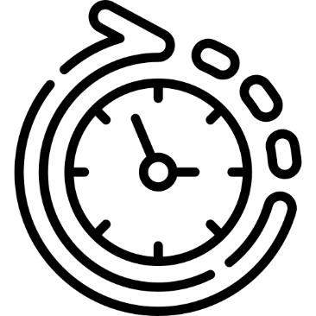
Day After Day After Day
Repetitive Strain Injury (RSI) happens when you constantly make the same movement again and again. It usually affects joints in wrists and fingers.
Ever played a game for a long time and got sore/numb thumbs? This is has been termed Nintendo thumb.
It can cause extreme pain and damage to the joints – in extreme cases resulting in arthritis.
Combating this potential threat to your health, we can:
- Adjust your keyboard to a comfortable angle.
- Use a wrist rest
- Keep wrists straight when typing
- Take regular breaks

Hazards


Ergonomics
The science concerned with designing safe and comfortable hardware and office furniture for humans
Ergonomics is designing equipment suitable for humans – for example, PlayStation has officially altered its PS4 controller 3 times, and Microsoft spent “hundreds of millions” designing its xBox One controller.
There is a reason companies spend so much creating these ergonomic products – it’s so you can spend longer using their products with less chance of ‘getting sore’ or ‘requiring breaks’. It’s all a marketing ploy to ensure you keep using their products. But it’s very important to remember you need to keep your own safety in mind!


Cyber Security
As well as keeping ourselves protected when using ICT, we need to protect our data from being damaged.
There are many different data threats, including unauthorised users, or hackers, can gain access to data by illegal means. Hackers often use computer viruses, which can attack and seriously damage files. They can also cause system crashes which affect the hard drive may damage key sections of data.
Data can be lost accidentally or deleted by mistake, or even be sabotaged by former employees who are guilty of committing malicious acts. This is called an insider threat, but it is not always intended. Some employees are involved in careless insider threats. These employees are called pawns or goofs depending on the circumstances. We will discuss these further at GCSE.

Employer Regulations
Employers have a duty of care to their employees when using ICT. This is covered in the Health and Safety at Work Act, which was formally introduced in 1974. It keeps both employees, employers, data and equipment safe when using ICT, or and computer related equipment as part of their work duties.
It sets out the general duties which:
- employers have towards employees and members of the public
- employees have to themselves and to each other
- certain self-employed have towards themselves and others
The Health and Safety at Work Act provides the legal framework to promote, stimulate and encourage high standards of health and safety in places of work. It protects employees and the public from work activities which involve IT.

